**Lab03 Global autocorrelation**

Due:

Today, we are going to conduct spatial autocorrelation, especially ‘global spatial autocorrelation.

Learning Objectives: When you have completed this lab, you will be able to

1. Understand the concept of spatial autocorrelation.
2. Install the Packages you need.
3. Mount the drive with your google colab and export files.
4. Map the results.

Part 0. Understanding Spatial Autocorrelation

Luc Anselin, who is one of the developers of the field of spatial econometrics, quoted the notion of the spatial autocorrelation as ‘functional relationship between what happens at one point in space and what happens elsewhere’ in 1988. This means the similar values between observations in the dataset have some relationships to the similar locations. With analogical context, spatial autocorrelation can be extended to temporal counterpart, temporal autocorrelation. A series of periods is related to a given time point.

The key to the spatial autocorrelation is spatial randomness which a situation in which the location of observation gives no information. If its distribution follows no explicit spatial pattern, that defines as the ‘absence of spatial randomness’. The spatial autocorrelation can be categorized into sign and scale dimensions. Then it can adopt positive and negative main forms. In other words, former is related to geographical closeness which similar values are located near each other while different values tend to be scattered. Thus, negative spatial autocorrelation reflects the similar values tend to be located far from each other.

This exercise covers global spatial autocorrelation, which considers the overall trend of the location values. It makes possible to estimate the degree of clustering in the dataset. On the other hand, local autocorrelations focus specific area or levels then the entire map.

Part 1. Installing packages

To illustrate the notion of spatial autocorrelation and other some variants, let’s import all relevant libraries that we will use through this chapter. Google colab basically provides some packages, but not all libraries are built in. For example, we need to install pysal, contextily, geopandas for graphics later.

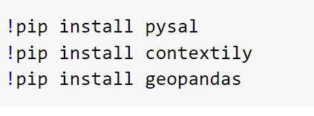

Next, let’s import all the packages for graphics and analysis like down below.

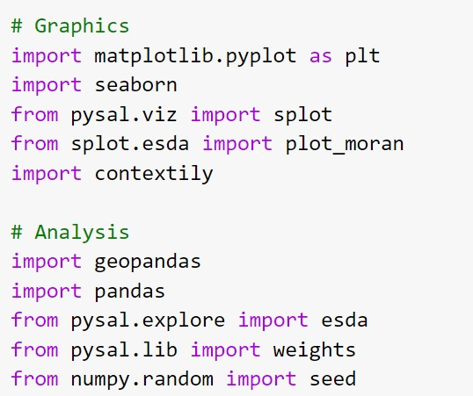

Part 2. Mounting google drive and exporting files

In 2016, the United Kingdom had a vote whether to remain in the EU(European Union) or to leave its club. This so called “Brexit” vote. We are going to use the he official data from the Electoral Commission at the local authority level on percentage of votes for the Remain and Leave campaigns. There are two distinct datasets we will combine:

* Electoral Commission data on vote percentages at the local authority level. [CSV]
* ONS Local Authority Districts (December 2016) Generalized Clipped Boundaries in the UK WGS84. [SHP]

Before combine these two files, mounting google drive step is needed. This connects your drive with your working pages.

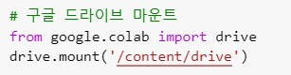

To import first csv file, the path should be accurate. Go to file icon and click ‘My Drive’ and find ‘Brexit_vote.csv’ file. Again right click and press copy press.

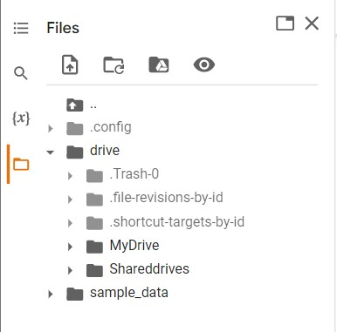

Paste it between “” and click run.

The result should be look like this. It shows the field and Dtype.

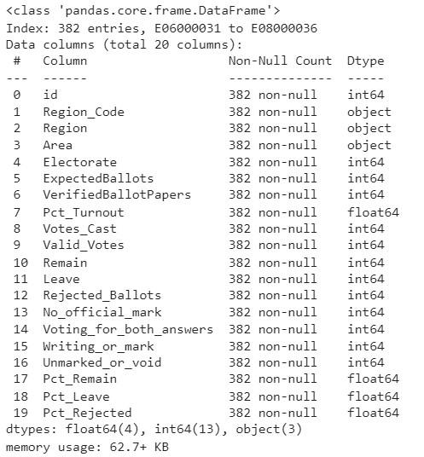

Repeat similar step to SHP file. (File format is Geojson).

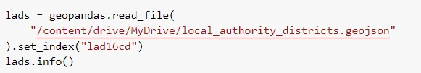

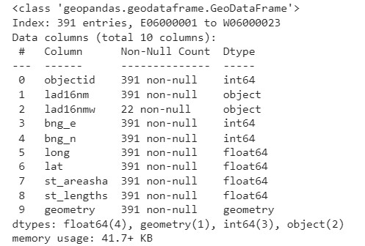

Part 3. Merge Files

We will focus on Pct_Leave, which measures the proportion of votes for the leave alternative. Let’s merge the vote results with the spatial data and project the output into the Spherical Mercator coordinate reference system (CRS).

The output should be followed like picture down below.

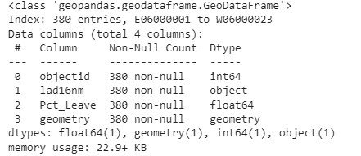

Part 4. Making a map

With those elements, we can make a choropleth map of visualizing of the spatial distribution. Each code line accords to the specific setting of the map. That means, you can change some values.

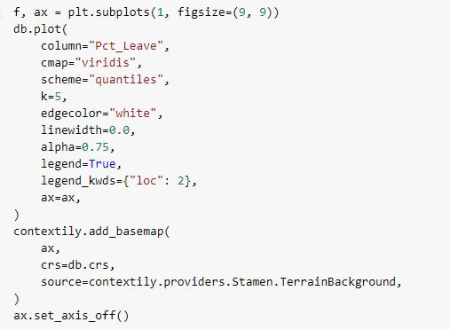

The final piece we need before we can delve into autocorrelation is the spatial weights matrix. We will use eight nearest neighbors for the sake of the example.

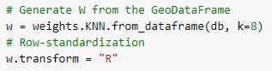

**다 돌아가기는 하나 Moran’I, Getis-G 여기부분이 하이라이트인데 코드 이해를 못했다.. Spatial lag part 부터**

Assignment!!

1. Export a map and submit in pdf file.